**First Aid at Work**

1. **Statement of Intent**
   1. The aim of this policy is to ensure that there are sufficient numbers of competent first aid personnel available to deal with accidents and injuries occurring at work. Allied to this, is the provision of adequate training and equipment to ensure that the statutory requirements and needs of the organisation are met.
   2. It is the personal responsibility of every individual referring to this policy to ensure that they are viewing the latest version.
   3. This policies applies to all places of work operated by Omega Care Group.
2. **Introduction**
   1. Background People at work can suffer injuries or fall ill, irrespective of whether the injury or illness is caused by the work that they do. What is important is that they receive immediate attention and that an ambulance is called in serious cases.
   2. First aid can save lives and prevent minor injuries becoming major ones.

The five most common scenarios when people need first aid include:

* + - Severe bleeding.
    - Choking
    - Heart attack.
    - Unconscious but breathing.
    - Unconscious and not breathing.
  1. The Health and Safety (First Aid) at Work Regulations 1981 (as amended 2009) cover the arrangements that need to be made, with the key emphasis on suitable and sufficient cover.
  2. The level of first aid cover needed should be determined by carrying out a risk assessment of the risk exposures within individual workplaces. The arrangements do not include giving tablets or medicines to treat illness.

1. **Definitions**
   1. Throughout this policy the term “child” will refer to children and young people.
   2. First Aid occasions or situations is where a person will need help for the purpose of preserving life and minimising the consequences of injury and illness until such help is obtained.
   3. First Aider
      1. An employee who undertakes first aid duties associated with Omega Care Group and who holds a valid certificate of competence (e.g. first aid at work issued by the organisation whose training and qualification are approved by the Health and Safety Executive (HSE).
   4. Appointed Person
      1. An employee who takes charge of a situation if a serious illness/injury occurs in the unforeseen absence of a qualified First Aider and ensures that processes are in place to manage that situation.
2. **The Legal Framework** 
   * + The Health and Safety (First Aid) Regulations 1981 (as amended 2009): The Approved Code of Practice and Guidance
     + The Health and Safety at Work etc. Act 1974
     + The Management of Health and Safety at Work Regulations 1999.
     + The Reporting of Injuries, Diseases and Dangerous Occurrences Regulations 1995.
     + The Children’s Homes Act 2015
3. **Responsibilities** 
   1. Home Manager (including Seniors and Deputies)
      1. Are responsible for the safe undertaking of all aspects of work under their control. Where hazards and risks are identified, it is the Manager’s duty to take action to prevent harm occurring and to put in place such measures as are necessary.
      2. All Managers have a responsibility to risk assess within their areas of responsibility, to identify an appropriate level of first aid provision. If the assessment identifies a significant level of risk, it may be that an approved First Aider will be required, which will involve attendance at an appropriate training course.
      3. Home managers must ensure the First Aid Risk Assessment is done annually and is stored correctly in the first aid file with the first aid inventory documentation.
      4. The Health and Safety Policy places the responsibility for identification of health and safety training needs with the home’s Manager.
      5. Home Managers must ensure at all time there is at least one first aider available
      6. First Aid Risk Assessment will support the house manager to determine what appropriate first aid measures should each home hold.
      7. The home manager duty to ensure accurate records are being obtained safely and securely.
      8. Home managers must ensure that all employees are notified of first aid arrangements for the workplace and that the correct signage is displayed within it. This is white markings on a green background and should clearly name the First Aiders and Appointed Persons. Signs should also identify the location of first aid boxes.
      9. Home Managers must ensure that employees are familiar with the identity of their nearest First Aider and location of the nearest first aid box.
      10. Home Managers must also ensure that first aid boxes are accessible at all times. The names and locations of first aid personnel and equipment must be displayed and regularly updated in the homes’ monthly risk assessment.
      11. Home Managers must ensure their workforce hold the appropriate level of first aid training and complete training at the required intervals in order to comply with current legislation and to ensure that their skills are maintained.
      12. All First Aiders are required to provide first aid in the event of an incident, in keeping with their level of training. All details following the incident should be entered onto the accident form. All items used from the first aid box should be replaced by the First Aider at the earliest opportunity.
      13. Home managers must ensure copies of all staff first aid at work certificates are held at each home.
   2. Employees
      1. Every employee has a duty under health and safety legislation to take reasonable care of the health and safety of themselves and that of any other person who may be affected by their acts or omissions whilst at work.
      2. Employees should also make themselves familiar with the first aid arrangements provided and, in particular, with the name and location of their nearest First Aider and first aid box. It is everyone’s responsibility to report any matters that present a serious and immediate danger or where there are shortcomings in the arrangements that have been made for health and safety.
      3. The reporting of hazardous and unsafe conditions is therefore a statutory duty of every employee. All staff are responsible for ensuring the first aid checks are completed at the required monthly intervals.
      4. All staff access mandatory, appropriate on-line First Aid awareness training.
4. First Aid Equipment
   1. 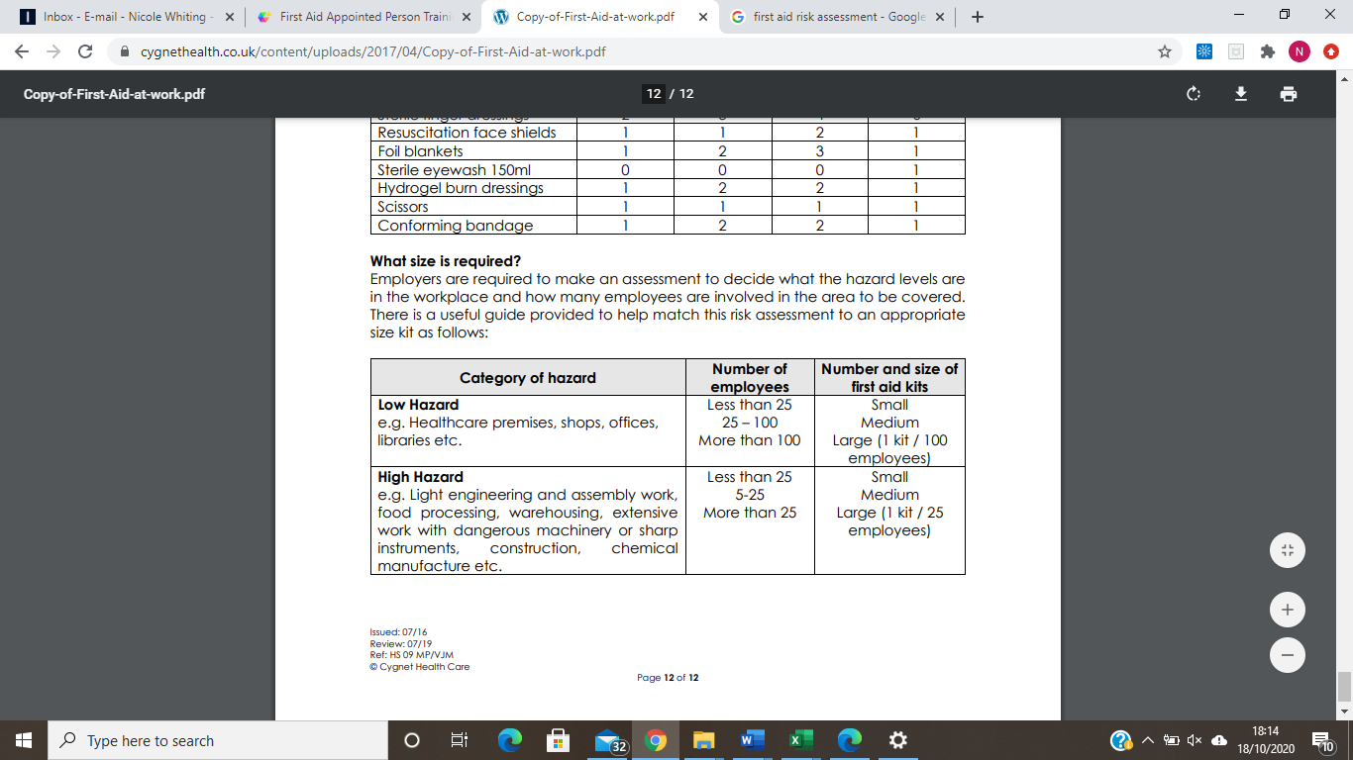House Managers are required to assess the level of harm of each hazard present in the home. The following table is a useful guide to support the manager in determining which first aid kit would be suitable for their workforce.
   2. All homes should hold at least a medium size first aid kit in the office and a small first aid should be carried when using any vehicles.
   3. The content of the first aid kit must comply with the British Standard Compliant (BS 8599-1:2019) First Aid for the workplace:

|  |  |  |  |
| --- | --- | --- | --- |
| **Contents** | [**Small**](http://evaq8.co.uk/First-Aid-Refill-Pack-British-Standard-BS8599-1-Small.html) | [**Medium**](http://evaq8.co.uk/First-Aid-Refill-Pack-British-Standard-BS8599-1-Medium.html) | [**Large**](http://evaq8.co.uk/British-Standard-BS8599-1-First-Aid-Refill-Pack-Large.html) |
| F/A guidance leaflet | 1 | 1 | 1 |
| Medium sterile dressing | 2 | 4 | 6 |
| Large sterile dressing | 2 | 3 | 4 |
| Triangular dressing | 2 | 3 | 4 |
| Eye dressing | 2 | 3 | 4 |
| Adhesive dressings | 40 | 60 | 100 |
| Sterile wet wipe | 20 | 30 | 40 |
| Microporous tape | 1 | 2 | 3 |
| Nitrile gloves - pair | 6 | 9 | 12 |
| Face shield | 1 | 2 | 3 |
| Foil blanket | 1 | 2 | 3 |
| Burn dressing 10 x 10cm | 1 | 2 | 2 |
| Clothing shears | 1 | 1 | 1 |
| Conforming bandage | 1 | 2 | 2 |
| Finger dressing | 2 | 3 | 4 |
| Sterile eyewash 250ml | 0 | 0 | 0 |

* 1. This should be checked at the relevant monthly interval and documented in the First Aid inventory which is stored in the first aid file.

1. **Guidance and Information** 
   1. An appropriately stocked First Aid box is sited in the office. Contents should be checked weekly and restocked as is appropriate, contents should also be checked following an incident.
   2. Plastic gloves **must be used** whenever blood or bodily fluids are involved.
   3. Any blood spillages/soiled equipment should be disposed of appropriately and safely. The area and any remaining spillages should be treated with sterilizing wipes.
   4. Should a member of staff fall sick whilst at work they should notify a Manager immediately in order for them to make appropriate provision.
   5. Should the member of staff be operating as a Lone Worker, they should contact the on-call Duty Manager immediately to make emergency provision.
   6. Children & Young People
      1. If the incident requires a greater level of treatment, they will be supported to attend the nearest walk-in centre. All treatment, advice and recommendations should be recorded.
      2. If the incident requires emergency treatment, the staff on duty should ring 999 and provide details of facility address, the nature of the injury/concern and the age/gender of the child.
      3. If the child attends hospital and remains there, there is a requirement to report this to the HSE. If they are examined and able to return home this is not necessary.
      4. Social care or EDT should be informed as soon as is practicable and the telephone call supported by an e-mail containing all relevant details.
2. **Recording and Reporting**
   1. Each home maintains a HSE Accident Book, which is to be completed in full following **any** incident. Only one book should be in used at one time and the serial number of the accident contains the first two letters of the home following the number of the incident e.g. Ne001, Ne002.
   2. It is the home’s managers responsibility to ensure the details of the book is completed correctly.
   3. Omega’s Strategic team will audit accidents across Omega annually and create and develop interventions and strategies to reduce hazards.
   4. It is the responsibility of the employee on duty to ensure the individual accident sheet is filled out correctly, then scanned to [accidentcr@omegacaregroup.org](mailto:accidentcr@omegacaregroup.org) (children residential service only) upon receipt of email, this sheet must be shredded for the purpose of data protection.
   5. It is the responsibility of the employee on duty to ensure the individual accident sheet is filled out correctly, then scanned to [accidents@omegacaregroup.org](mailto:accidents@omegacaregroup.org) upon receipt of email, this sheet must be shredded for the purpose of data protection.
   6. In the event of the accident involving a child, a further report should be reported for the purpose of the child’s file.
   7. Certain accidents and incidents are Reportable to the Health and Safety Executive (see: reporting section in Health and Safety file). This responsibility is held with the strategic management team.
   8. Certain accidents and incidents must be reported to RIDDOR, this responsibility is held with the strategic management team.
   9. If the accident is deemed as serious, it is the responsibility of the home’s manager to ensure the relevant regulatory body and other stakeholders are aware. This may include placing or hosting local authorities.
   10. It is the Strategic Management team’s responsibility to inform contractors provider if necessary.